A (very much abridged) Political History of English Civil War History
Relevant to Classical Social Contract Theory

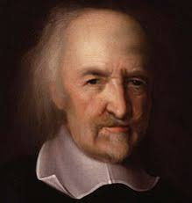 | 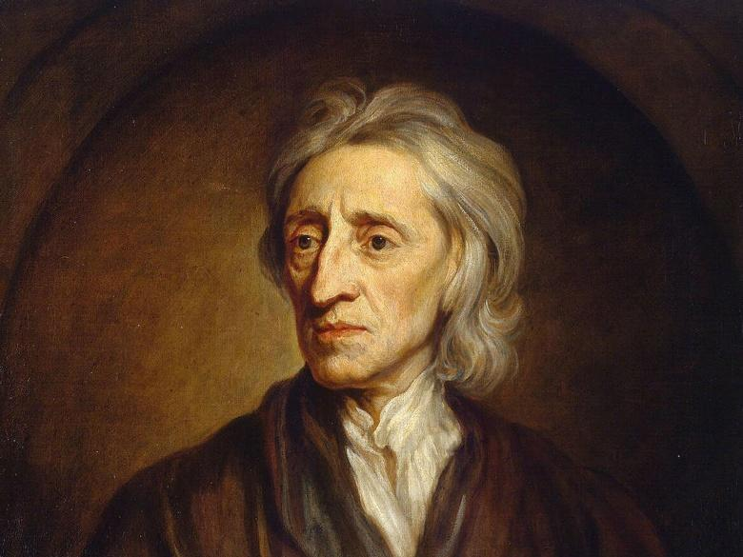
Thomas Hobbes (1588 – 1679)  Focal text: Leviathan  published 1651 | John Locke (1632 – 1704)  Focal text: Two Treatises of Government (Second treatise) published 1689

1625 – Charles I is crowned King of England, Scotland, and Ireland

1628 – Petition of Right is passed by Parliament, declaring a variety of restrictions to the power of the Sovereign, including with regards to legitimate conditions in which the Sovereign can levy taxes without parliamentary approval

1628 - 1635 – the Ship Money case: repeated attempts by Charles to levy “Ship Money” inland and during peace time, a tax usually applied to coastal areas only to raise money for war efforts. The attempts met fierce resistance from landowners and Parliament.

1629 – 1640 – “Personal rule” of Charles I, ruling without recourse to Parliament

April - May 1640 – the Short Parliament: Parliament is recalled by Charles primarily to raise money for military efforts against Scotland. It lasts just three weeks, with Charles dissolving Parliament after resistance to his fund-raising efforts and attempts to revive debates about Crown privilege

April 1640 – Hobbes finishes pro-royalist treatise Elements of Law, flees to Paris

Nov 1640 – start of the Long Parliament: Parliament recalled, again to raise funds, but this time with the proviso that it could be dissolved only with the agreement of MPs

1642 – 1651 – English civil war: multiple violent armed conflicts and political battles (too numerous to go into detail here!)

1649 – Execution of Charles I

1649 – 1653 – Parliament governs England as a Commonwealth (no Sovereign!)

1651 – Hobbes publishes Leviathan, returns to England

1653 – 1658 – Oliver Cromwell rules England as the “Lord Protector”

1658 – 1660 – Oliver Cromwell dies, Parliament resumes government of England

1660 – England had fallen back into political crisis after the death of Cromwell. In an effort to restore stability, the monarchy is restored, and Charles II crowned. Monarchy reigns only with consent of Parliament

1679 – 1681 – House of Commons thrice unsuccessfully attempts to enact “Exclusions bills”, frustrated in doing so by Charles II. The Exclusion bills were designed to prevent Charles’ brother and presumed heir, James, from taking the throne because he was a Roman Catholic.

1681 – 1683 – Whig plots for insurrection and regicide are foiled

(1679 – 1683 – Locke’s Two Treatises are likely written during this time)

1685 – Charles II dies, James II succeeds him

1688 – William of Orange successfully invades England, backed by Parliament. James II flees

1689 – Parliament crowns William

1689 – Locke publishes (anonymously) Two Treatises of Government

Recommended further reading:
JR Milton ‘Locke’s life and times’ in Cambridge Companion to Locke
Noel Malcolm ‘A Summary Biography of Hobbes’ in Cambridge Companion to Hobbes, especially pp.26 - 33
Quentin Skinner Visions of Politics, Vol 3, esp chaps 9 and 10

