Suffering and Tragedy

This week we focus on The Birth of Tragedy, published in 1872. The book has an immediately apparent, narrowly academic theme, and a more interesting theme that is less immediately apparent.

Narrowly academic theme: to explain how Attic tragedy developed from earlier art forms in Greece and Asia minor

Broader theme: the role that Attic tragedy played as a cultural response to suffering

The Broader theme is an early sign of Nietzsche’s distinctive “hermeneutics of suspicion”: a critique that asks why we have adopted our beliefs and practices, and what purposes they serve for us. In this early work, Nietzsche’s object of critique is Attic tragedy. In later work, it will turn to modern moral culture.

What is tragedy? Aristotle offers one particularly influential account:

- Tragedy is a representation of an action that is heroic and complete and of a certain magnitude—by means of language enriched with all kinds of ornament, each used separately in the different parts of the play: it represents men in action and does not use narrative, and through pity and fear it effects relief [catharsis, κάθαρσιν] to these and similar emotions.
(Aristotle, Poetics, 1449b; translation from perseus.tufts.edu)

Three of the best know Greek tragedians were Aeschylus (the Oresteia, Prometheus Bound), Sophocles (Oedipus Tyrannus, Oedipus at Colonus, Antigone) and Euripedes (Electra, Phonician Women, Orestes)

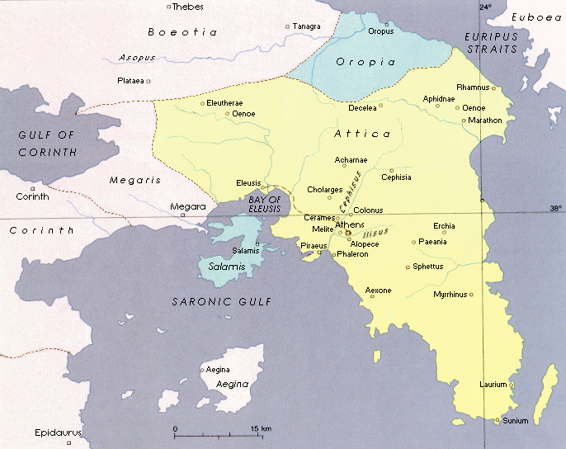
Attica (hence Attic tragedy)
One of the primary questions for Nietzsche in the Birth of Tragedy is: from whence did tragedy emerge?

- […] We are now drawing closer to the true goal of our study, the aim of which is to understand the Dionysian-Apollonian genius and its work of art, or at least to gain some tentative intimation of that mysterious unity. At this point our first question is: where in the Hellenic world did that new germ first become evident which later evolved into tragedy and the dramatic dithyramb? […]
(The Birth of Tragedy, §5)

But Nietzsche’s real interest is in the significance of tragedy for Greek culture and the lesson we can take from that. His most important thesis in the work is pithily expressed in its most famous line:

- […] we may very well assume we are already images and artistic projections for the true creator of art, and that our highest dignity lies in our significance as works of art – for only as an aesthetic phenomenon is existence and the world eternally justified – although, of course, our awareness of our significance in this respect hardly differs from the awareness which painted soldiers have of the battle depicted on the same canvas. […]
(The Birth of Tragedy, §5)

What does Nietzsche mean by this? We can approach this by asking two further questions:

- What does Nietzsche mean by justifying the world and existence?
- Why does Nietzsche think the world is justified “as an aesthetic phenomenon”?

A What does Nietzsche mean by justifying the world and existence?

Why does existence need a justification? Perhaps because Silenus’ wisdom is true:

- An ancient legend recounts how King Midas hunted long in the forest for the wise Silenus, companion of Dionysos, but failed to catch him. When Silenus has finally fallen into his hands, the King asks what is the best and most excellent thing for human beings. Stiff and unmoving, the daemon remains silent until, forced by the King to speak, he finally breaks out in shrill laughter and says: 'Wretched, ephemeral race, children of chance and tribulation, why do you force me to tell you the very thing which it would be most profitable for you not to hear? The very best thing is utterly beyond your reach not to have been born, not to be, to be nothing. However, the second best thing for you is: to die soon.’
(The Birth of Tragedy, §3)

Perhaps the Greeks needed a justification for their existence because they were privy to some horrible, terror-inducing knowledge of an “eternal, primal pain”:

- The Greeks knew and felt the terrors and horrors of existence; in order to live at all they had to place in front of these things the resplendent, dream-born figures of the Olympians.
(The Birth of Tragedy, §3)

- Raphael…has depicted for us in a symbolic painting the reduction of semblance to semblance, the primal process of the naive artist and also of Apollonian culture. In his Transfiguration the lower half of the picture, with the possessed boy, the despairing bearers, and the frightened, helpless disciples, shows us a reflection of the eternal, primal pain, the only ground of the world
(The Birth of Tragedy, §4)

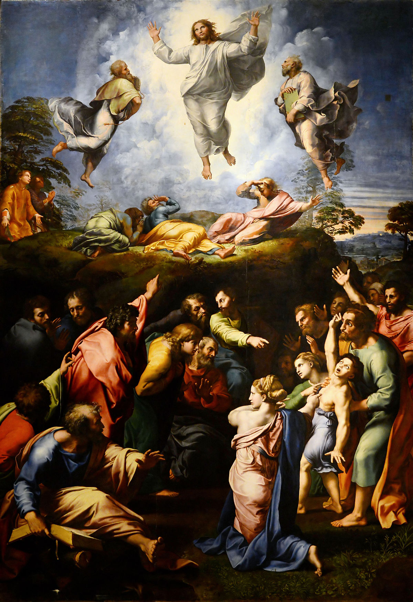

Raphael’s Transfiguration

What kind of suffering does it take to make never-having-been-born an attractive prospect? Nietzsche has one of two things in mind here.

Contingent Suffering: the Greeks endured a distinctive hardship that they happened to face due to contingencies of their societies

Necessary Suffering: Attic tragedy was a Greek response to a universal problem; the human condition is intrinsically painful

- […] Apollo overcomes the individual's suffering by his luminous glorification of the eternity of appearance; here beauty gains victory over the suffering inherent in life; in a certain sense, a lie is told which causes pain to disappear from the features of nature. […]
(The Birth of Tragedy, §16)

There are at least three reasons Nietzsche might have for thinking the human condition is intrinsically painful.

- Morality (my own death or the death of those close to me)
- Finitude (there are limits to how much I can make the world as I wish it to be)
- Schopenhauerian Pessimism

Schopenhauer’s influence on the young Nietzsche is hard to overstate. Nietzsche would, for instance, regularly gather with friends in a café in Naumburg to, in his words, “Schopenhaurianise”. One of those friends, Karl von Gersdoff, once tracked down the owner of a portrait of Schopenhauer by Jules Lunteschultz. Von Gerdsoff wrote the following to Nietzsche, which Nietzsche then circulated with admiration to other friends:

- I saw the heavenly picture of our master, before which one could stand for hours, in order to look into his clear eyes. A god-like brow that appears to rise to infinity, framed by beautiful white hair under white eyebrows like those of the Olympian Zeus, two eyes of clarity and depth from which one cannot tear oneself away, once one has become accustomed to the gaze which at first seems to dazzle one. The mouth is broad but has the friendly, mild expression of inner peace
(This is taken from Julian Young’s biography of Nietzsche Friedrich Nietzsche: a Philosophical Biography, chapter 5)

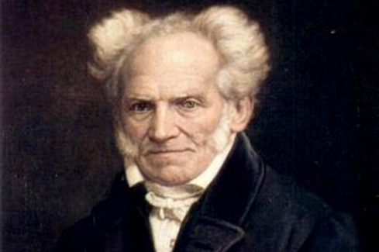

Jules Lunteschultz’s portrait of Arthur Schopenhauer

Schopenhauer argued that we have an awareness of reality in itself latent in our immediate knowledge of our own will. Just as action seen from the perspective of the agent is a perspective of acting or willing, so too is all reality revealed to be “the Will” from viewed from reality’s “inner perspective”, as opposed to its observation through experience. But this metaphysical knowledge reveals that reality is, in itself, a directionless hunger that can never be sated, and thus can only produce eternal frustration. Hence Schopenhauerian pessimism.

Whether Nietzsche thought suffering was contingent or necessary, it was clear that he thought justifying existence meant giving a reason to live in the face of tremendous pain. In this respect he anticipated e.g. Albert Camus:

- There is but one truly serious philosophical problem, and that is suicide. Judging whether life is or is not worth living amounts to answering the fundamental question of philosophy. All the rest— whether or not the world has three dimensions, whether the mind has nine or twelve categories—comes afterwards.
(Albert Camus, opening lines of The Myth of Sisyphus)

(NB: not all agree that Schopenhauer’s metaphysics remained influential for Nietzsche when he came to write BT. See Beatrice Han-Pile 'Nietzsche’s Metaphysics in the Birth of Tragedy', European Journal of Philosophy, 19, no. 2 (2011): 224-61.)

B Why does Nietzsche think the world is justified “as an aesthetic phenomenon?”

Nietzsche’s analysis of Attic tragedy is framed by two aesthetics categories: Apollonian and Dionysian:

- […] [The Greeks’] two deities of art, Apollo and Dionysos, provide the starting-point for our recognition that there exists in the world of the Greeks an enormous opposition, both in origin and goals, between the Apollonian art of the image-maker or sculptor (Bildner) and the imageless art of music, which is that of Dionysos. These two very different drives (Triebe) exist side by side, mostly in open conflict, stimulating and provoking (reizen) one another to give birth to ever-new, more vigorous offspring in whom they perpetuate the conflict inherent in the opposition between them, an opposition only apparently bridged by the common term 'art' […]
(The Birth of Tragedy, §1)

Apollonian art: the use of figurative art forms to create individuated artistic objects, associated with the symbolic creativity of dreams, and used to render life intelligible. Nietzsche treats Apollonian art as the aesthetic equivalent of Schopenhauer’s principle of individuation: that objects of experience are individuated by their position in space, time, and on a causal chain.

- […] the image of Apollo must also contain that delicate line which the dream-image may not overstep if its effect is not to become pathological, so that, in the worst case, the semblance would deceive us as if it were crude reality; his image (Bild) must include that measured limitation (massvolle Begrenzung), that freedom from wilder impulses, that wise calm of the image-making god.
(The Birth of Tragedy, §1)

Dionysian art: non-figurative, lyrical/musical art form, associated with intoxication and orgiastic revelry e.g. practiced in religious rites in worship of Dionysus. Dionysian art is capable of generating a form of the immediate awareness of will that Schopenhauer suggests gives us access to knowledge of “things in themselves”.

- The music of Apollo was Doric architectonics in sound, but only in the kind of hinted-at tones characteristic of the cithara. It keeps at a distance, as something un-Apollonian, the very element which defines the character of Dionysiac music (and thus of music generally): the power of its sound to shake us to our very foundations, the unified stream of melody and the quite incomparable world of harmony. In the Dionysiac dithyramb35 man is stimulated to the highest intensification of his symbolic powers; something that he has never felt before urgently demands to be expressed: the destruction of the veil of maya, one-ness as the genius of humankind, indeed of nature itself
(The Birth of Tragedy, §2)

How does Attic tragedy combine the two? Spectators watch the tragedy’s chorus sing and dance in the orchestra in the centre of the theatre (see diagram below). The chorus perform the function of Dionysian art. Masked actors eventually enter the stage from the skene/scene, bringing a figurative, Apollonian expression to the emotional themes conveyed by the chorus. The Dionysian chorus confronts spectators with “the terrors of existence”. The Apollonian figures and their stories played out on stage give that truth a noble, beautiful form.

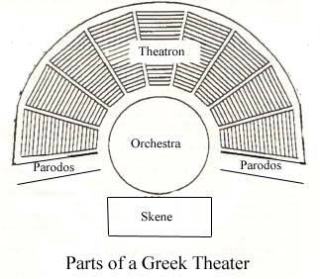

Nietzsche’s suggestion is that Attic tragedy helps its audience to confront the “terrible truth” of the painfulness of existence while at the same time seeing that painful existence as beautiful. Tragedy thus, in Nietzsche view, gives us a reason to live by showing us that life can be beautiful at the same time as being painful – indeed, that one can experience the same phenomenon as both painful and beautiful.

Additional reading relevant to this week’s lecture:

- Daniel Came ‘The Aesthetic Justification of Existence’ in A Companion to Nietzsche Blackwells, 2005
- Ivan Soll ‘Schopenhauer as Nietzsche’s “Great Teacher” and “Antipode”’ in The Oxford Handbook of Nietzsche
- Michael Tanner Nietzsche: a Very Short Introduction Oxford University Press, 2000. Chapter 2
- Julian Young Friedrich Nietzsche: A Philosophical Biography Cambridge University Press, 2010

Next week: Master and Slave Moralities
Main relevant texts:
On the Genealogy of Morality Essay 1
Beyond Good and Evil Chapter 5

Additional Admin

- Lecture schedule this term:

Week 1 – Nietzsche the immoralist
Week 2 – Suffering and tragedy
Week 3 – Master and slave moralities
Week 4 – Moralism and guilt
Week 5 – Genealogy
Week 6 – Freedom and fate
Week 7 – Will to power
Week 8 – Truth and perspectivism

- Reading group: The Gay Science

Fridays 12-1pm, weeks 2 - 8
Faculty of Philosophy Graduate Common Room

Reading for first session: Book I, sections 22-56 (inclusive)

Matt Bennett
Email mpb74@cam.ac.uk
Website (including teaching materials): drmattbennett.weebly.com

